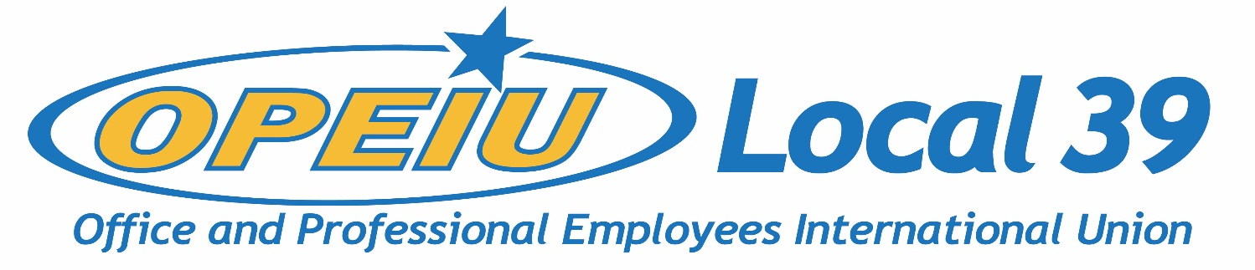

CUNA MUTUAL GROUP UNWILLING TO BARGAIN BEFORE STRIKE
May 4th, 2023
FOR IMMEDIATE RELEASE
On 5/3/21, representatives from CUNA Mutual Group (CMFG) and OPEIU 39 met for a first joint mediation session. Federal Mediation and Conciliation Services (FMCS) Mediator Tom Olson met with the parties independently the prior week before convening a meeting with labor and management together. The purpose of the meeting was to establish a path back to the bargaining table, choosing dates, times, and methods of bargaining session to occur (in-person or remote). Mediator Olson’s current availability over the next two weeks is limited to two days.
In an email from OPEIU 39 Chief Steward Joe Evica to the union members, Evica wrote, “The mediator strongly recommended the parties meet as frequently as possible--including outside of formal mediation meetings, to avert a potential strike. During the meeting, our Union put forward 10 full days to bargain between May 5th and May 18th. We offered to meet virtually, during the workday with bargaining pay and on the evenings and weekends without bargaining pay for all 10 days. The Company rejected every day our Union put forward except May 10th and May 16th.”
May 10th and May 16th are the two days Mediator Olson is available – as such, the Employer has rejected all other bargaining dates the Union offered to prevent a strike.
Evica’s email continued, “The Employer even failed to accept dates they claimed they were available to bargain in an email they sent to us the day before we met. Even with the two dates the Employer accepted, they could not confirm times to meet with our Union because they said they needed to consult with people outside of the meeting to make decisions regarding bargaining pay reinstatement. It appeared to us that Jim Denholm, the Company’s lead negotiator and VP of Labor Relations, did not have any authority to make decisions on behalf of the Employer.”
CUNA Mutual Group’s representatives left the mediation session early without committing to meeting times on the two agreed upon dates, citing another important meeting they had to attend. The next mediation date is presently scheduled for May 10th, approximately nine days before a strike would have to occur.
“What meeting could Jim Denholm possibly have which is more important than meeting with our Union to avoid a strike? This is completely unacceptable…We demand that the Employer take their responsibility to bargain seriously. We demand they stop stalling and bargain in good faith to reach a fair agreement,” said the Evica in an email to union members. OPEIU Local 39 has filed two additional Unfair Labor Practice charges following the meeting on May 3rd, for reneging on bargaining dates offered and failure to bargain with the employees’ representatives.
In correspondence with Denholm, OPEIU Local 39 President Kathryn Bartlett-Mulvihill said, “management’s agreement to only two days for bargaining as unacceptable, especially when there is mutuality on 6 dates...Your actions today, rejecting the mediator’s recommendation by not accepting more dates and admitting to having zero decision making authority indicates to us that management does not take OPEIU and the mediation process seriously.”
OPEIU 39 continues to press to return to the bargaining table and reach an agreement in hopes of averting a strike. The Union has sponsored a letter writing campaign to CMFG’s Board of Directors, available here: https://actionnetwork.org/letters/fair-contract-for-opeiu-39
#####
For more information, contact Kathryn Bartlett-Mulvihill:
president@opeiu39.org | 608-257-4734

