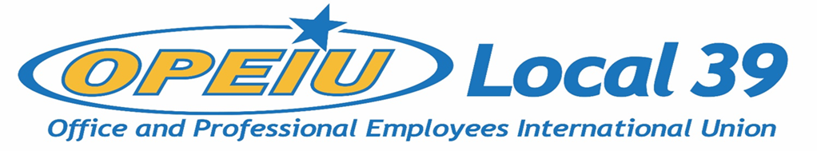

Membership Meeting Agenda
August 17, 2022

Officers
President – Kathryn Bartlett-Mulvihill (OPEIU L39)
Vice President – Tyler Albrecht (CMG)
Secretary Treasurer – Lori Richardson (IBEW L 965)
Recording Secretary – Kelsey Hahn (MG&E)
Trustee 1 – DeAnna Braaksma (CMG)
Trustee 2 – Mike Pionke (CMG)
Trustee 3 – open
Trustee 4 – open
Trustee 5 – JoAnn Hake (Verso Paper)
Trustee 6 – Debi Eveland (OPEIU L39)

Units
CMG Aspirus Hospital
CUNA Inc. Solarus
MG&E Domtar
ND Paper Sheet Metal Workers L-565
NCSRCC IBEW 965
Verso IBEW 953
NCSRCC Training Fund WEBBF
SCFL Operating Engineers L139
Sonoco IAMAW District Lodge 66
NECA – IBEW NCSRCC
Iron Workers L-383 IBEW 14
La Casa Norte Construction Business Group
IAM District 10 CRL – Center for Responsible Lending

Agenda
- Approval of Membership Meeting Minutes – May 18, 2022
- Membership Updates
- Business Reports
- Financial Reports
- New Business - Due to a number of active contract negotiations, the Executive Board has called for a Special Membership Meeting for August 31st, at 5:30pm, for E-Board Nominations instead of taking nominations on August 17th. The executive board seats up for election are for Vice President, Secretary-Treasurer, and Trustees number 1, 4, and 6. Members must be present to give a nomination. Those members receiving a nomination can verbally accept or decline if at the meeting or in writing within five days after such nomination (Article IX, Section 3, OPEIU Local 39 Constitution).

