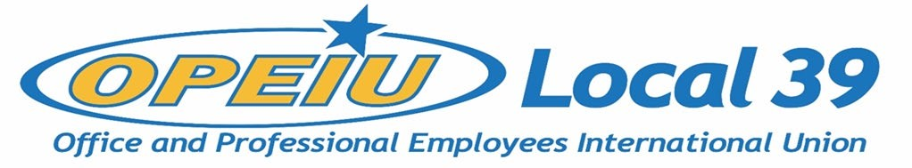

Membership Meeting Minutes
May 18, 2022

Meeting start 5:48 PM via Zoom

Officers
President – Kathryn Bartlett-Mulvihill (OPEIU L39) - present
Vice President – Tyler Albrecht (CMG) - present
Secretary Treasurer – Lori Richardson (IBEW L 965) - present
Recording Secretary – Kelsey Hahn (MG&E) - present
Trustee 1 – DeAnna Braaksma (CMG) - present
Trustee 2 – Mike Pionke (CMG) - present
Trustee 3 – open
Trustee 4 – open
Trustee 5 – JoAnn Hake (Verso Paper) - absent
Trustee 6 – Debi Eveland (OPEIU L39) - present

Units
CMG Aspirus Hospital
CUNA Inc. Solarus
MG&E Domtar
ND Paper Sheet Metal Workers L-565
NCSRCC IBEW 965
Verso IBEW 953
NCSRCC Training Fund WEBBF
SCFL Operating Engineers L139
Sonoco IAMAW District Lodge 66
NECA – IBEW NCSRCC
Iron Workers L-383 IBEW 14
La Casa Norte Construction Business Group
IAM District 10 CRL – Center for Responsible Lending

Agenda
- Approval of Membership Meeting Minutes – November 17, 2021 – Motion to approve Farwell, second Pionke, approved.
- Approval of Special Membership Meeting Minutes – December 15, 2021 – Motion to approve Farwell, second Walters. Approved.
- Membership Update – Bartlett-Mulvihill: around 650 members, so far only 1 opt-out since dues change. Pagac took another role, Eveland back to full time until a new BA is hired. Several contracts open (including CMG) or opening soon (including Solarus). Still working on initial contract for LCN. Bargaining remote work issue for new unit CRL, will start working on full contract soon. Eveland: CUNA Inc contract renewal done.
- Business Reports
- Financial Reports – Richardson: new dues just started, not showing in financial yet. Still receiving payments for Pagac contract from international, will end soon. DeNeve: How is the local handling the unit that did not make the proper adjustment to due amounts? Are retroactive adjustments being made? Bartlett-Mulvihill: has happened with prior dues amount changes as well; as in past, will be paid back retroactively once adjusted.

New Business
- Constitution update. The Executive Board will be looking for member volunteers. – Bartlett-Mulvihill: International has updated its constitution, need to incorporate their changes into our own as well as making updates specific to our local – dues etc. Looking for members to participate in process. DeNeve: Are we looking to just incorporate the International changes, or make more, which would require a vote to change? Mentions other potential changes – electronic meeting notice etc. Bartlett-Mulvihill: priority is international updates, but open to other changes if needed, which will have to be presented to membership and voted on.
- OPEIU Political Committee – OPEIU International looking to build a political presence in WI and NC for midterms and next presidential election. – Looking for membership participation.
- E-Board Nominations (VP, Treasurer, Trustees – 1, 6, 4) will be at the August 17, 2022, Quarterly Membership Meeting. If seats are contested then membership will be voted on at the November 16, 2022, Quarterly Membership meeting. – Bartlett-Mulvihill: board supposed to be split into two election blocks but got off track in early 2020 due to long period without quorum, putting both blocks on the same term period. Need quorum to run vote but not to accept nominations. Last elections done February 19, 2020. Board voted to end block 1 term early – November 2022 instead of February 2023. This will adjust election schedule back to two separate blocks. DeNeve: Do we have anything formal that can be provided to members explaining how we are not following our constitution for elections of officers, and the guidance from International on how to get back on track? Did we get written notice? Bartlett-Mulvihill: was a phone call, not written notice, but could include written materials/guidance in next meeting notice. DeNeve: are documents/posting on the website? Nothing available. Bartlett-Mulvihill: minutes not posted to website prior to 2021. Albrecht: we can provide minutes from prior meetings. Bartlett-Mulvihill: Have been looking into voting block issue since DeNeve raised initially; with difficulty getting quorum, needed to talk to int’l about best way to get back on schedule. Walters: before August meeting, can job descriptions for board member roles be posted? Bartlett-Mulvihill: yes, can provide for August meeting along with additional description/information. Albrecht: any additional concerns from DeNeve? DeNeve: Can we get a copy of motion approving schedule change with specific language? Bartlett-Mulvihill: Yes – will go in E-Board meeting minutes once approved. DeNeve: LM2 says next election July 2022, 2021, LM2 mentioned July 2021. Bartlett-Mulvihill: Need to confirm with preparer, July date is incorrect & has never been used for election period.
Motion to adjourn Albrecht, second Hahn. Adjourned 6:29 PM.

